**Dang Quoc Khoa**

**SD4591**

**PI-SHAPED**

**Just inform that in this section, we have some lines of codes that this document does not provide in detail because we have done it on the first program called “*Practical DevOps for Devs*”. This document will focus on the latest changes.**

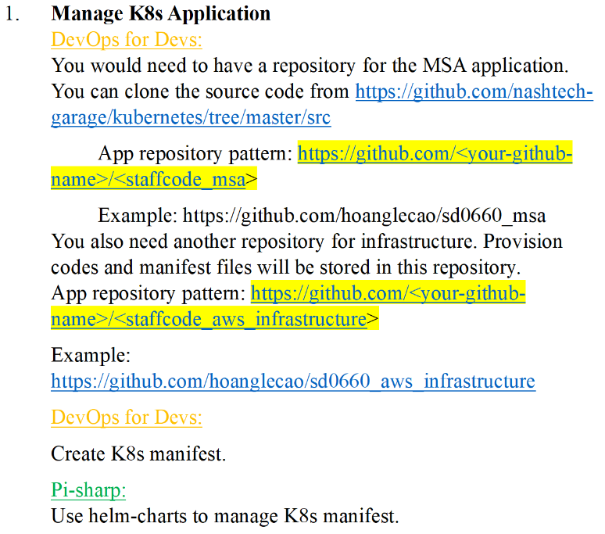

**After building and pushing the image to ECR (I have done requirements of 2-3-4-5 and then back to this requirement), we apply helm to project and update accordingly image information for each service.**

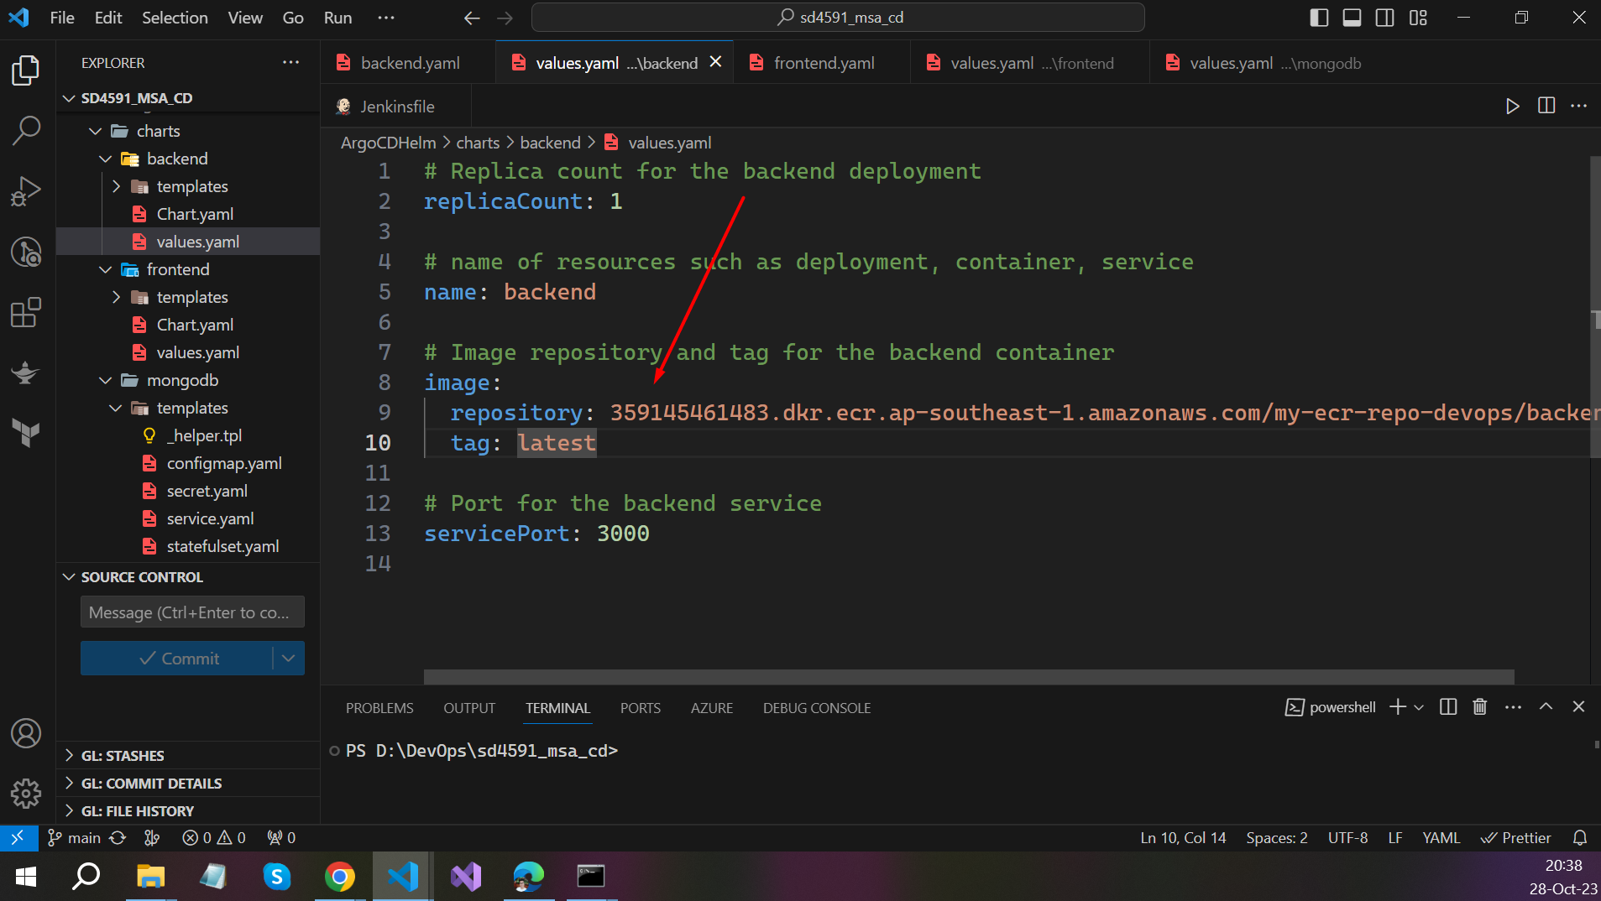

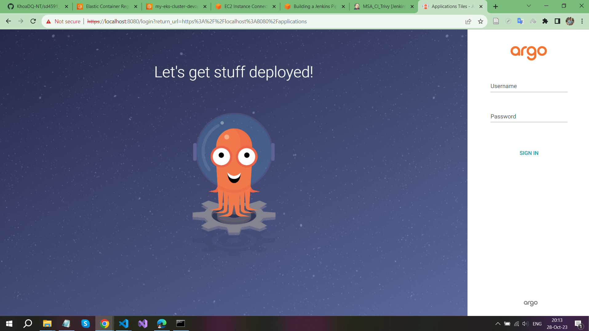

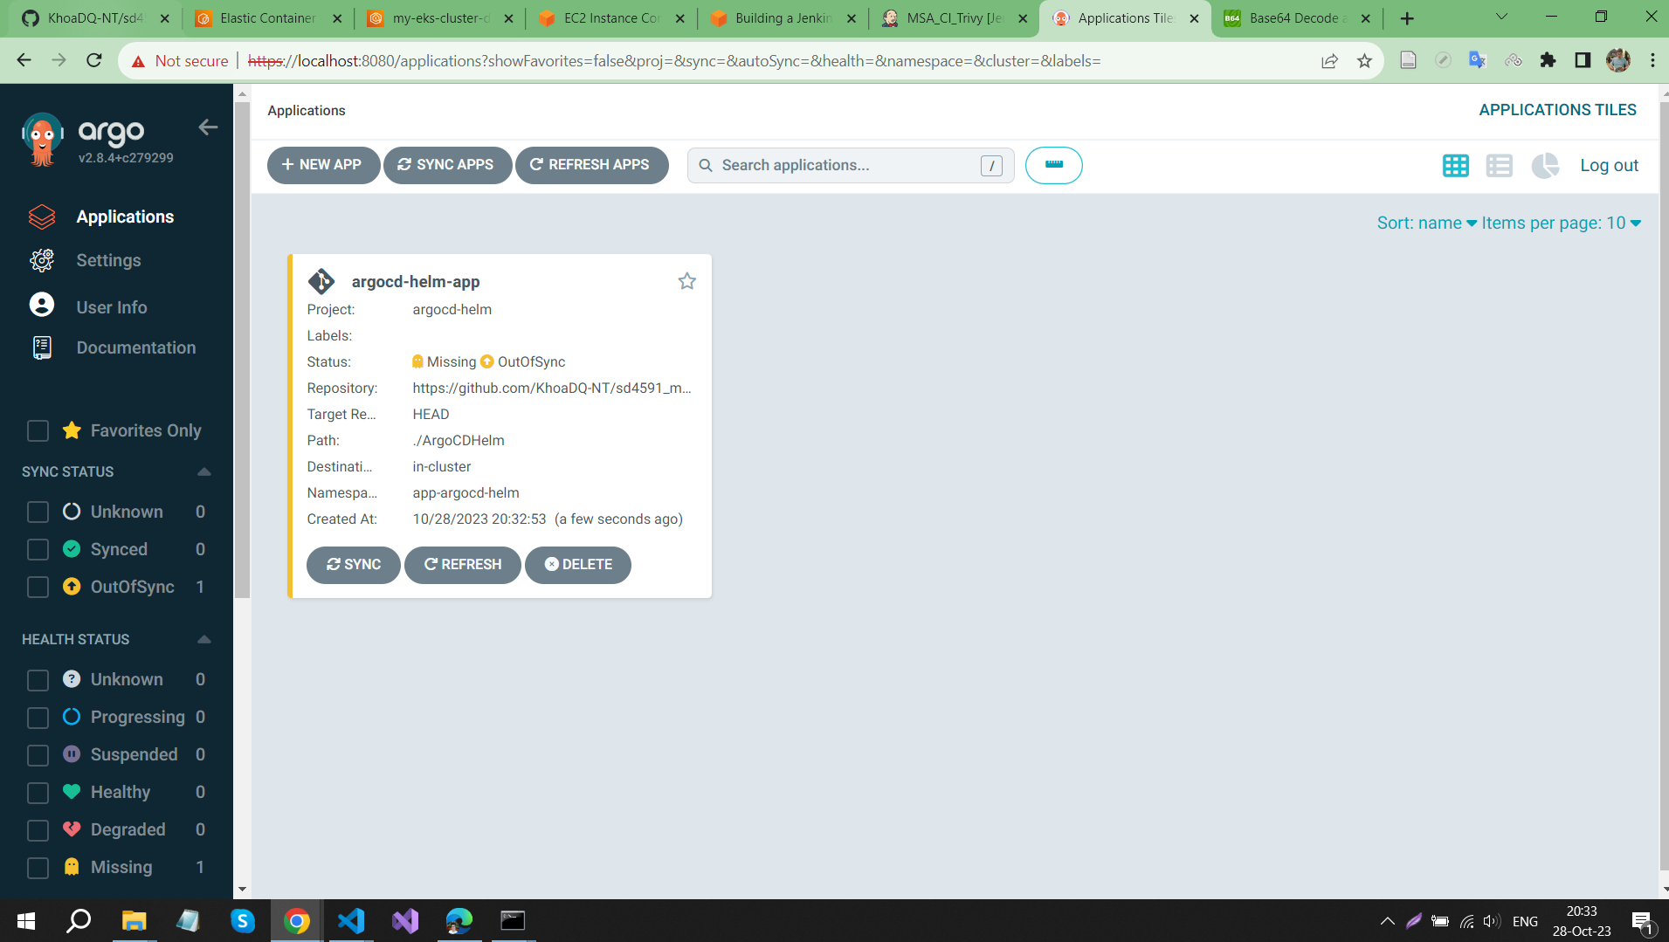

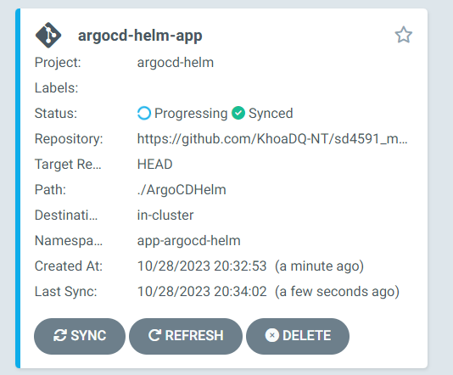

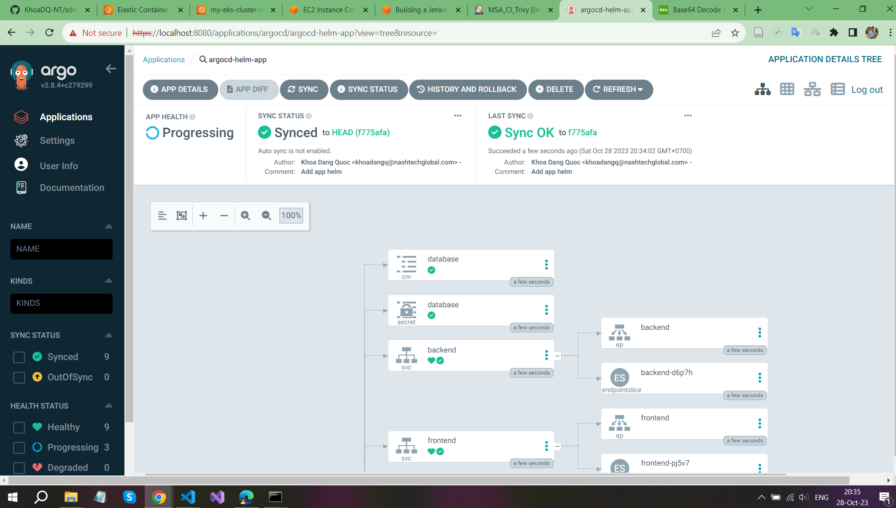

**My application is pending for a long time because the EBS does not have permission on volume, after investigating more on EBS driver and configuring exactly policy, it works OK**

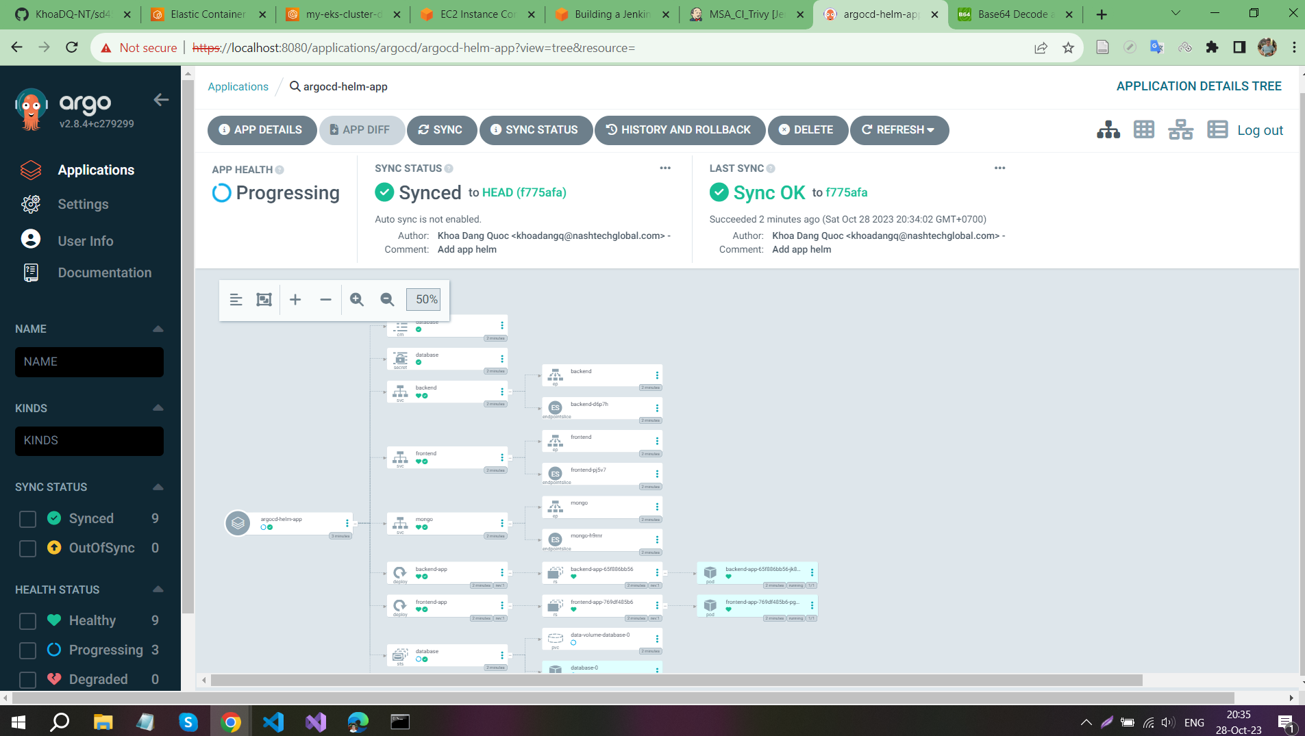

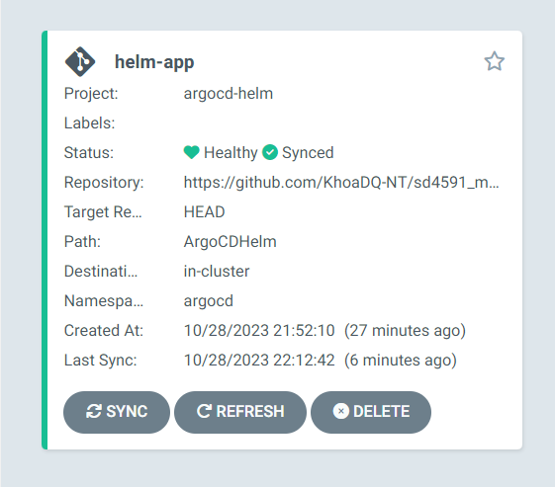

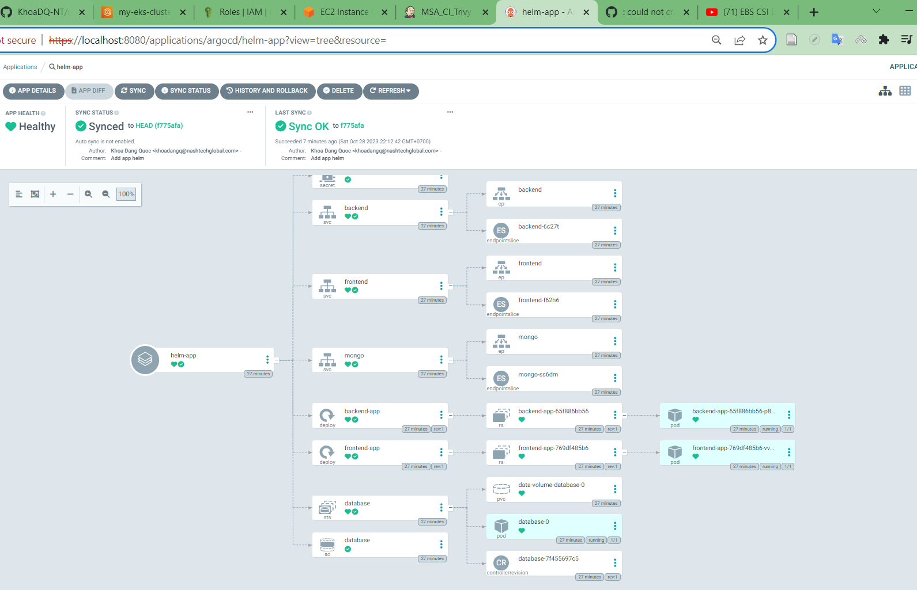

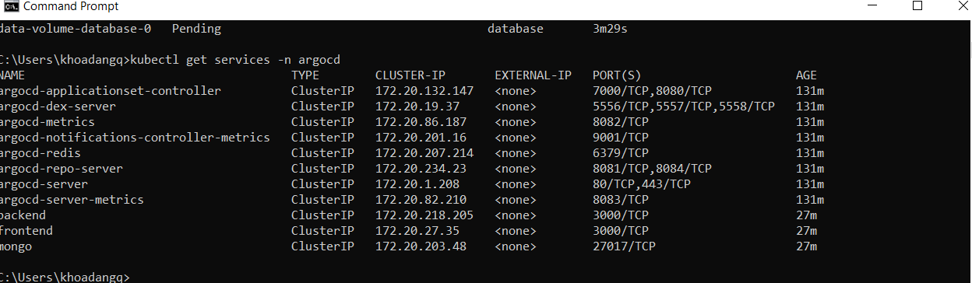

**After all services were “running” we need to port forward to using application on local**

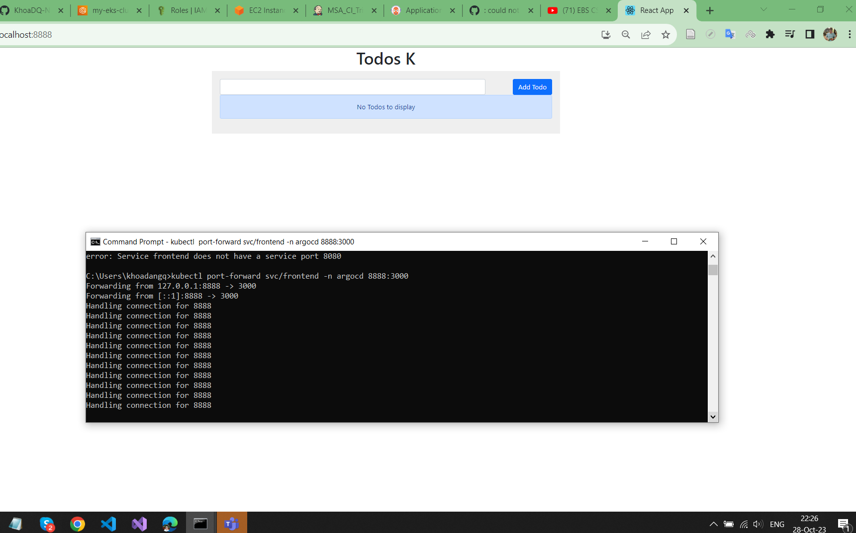

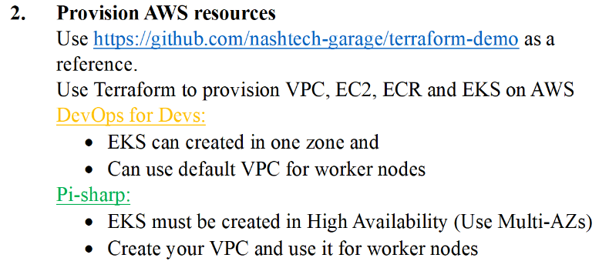

**I need to create a custom VPC as requirement, so that I have made some changes on my Infrastructure source code for using Terraform to deploy all necessary AWS services**

**The I mage below shows you my custom VPC**

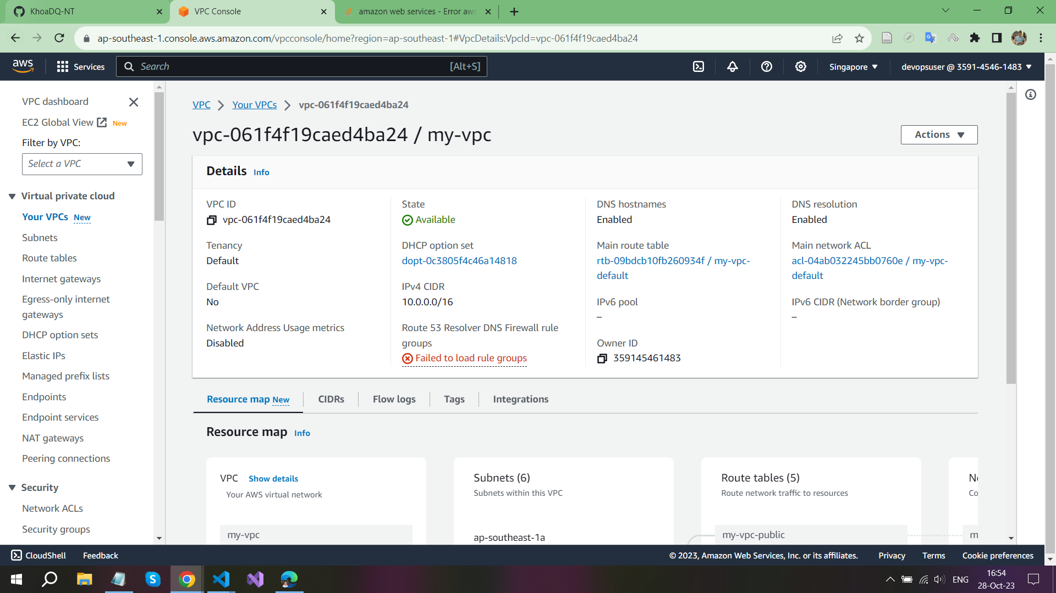

**The EC2 instances will be deployed in multiple zones within a region, that will make our instances more “High availability”, the ability to operate continuously without failing for a designated period of time. The main code changes on creating EC2 is showed below**

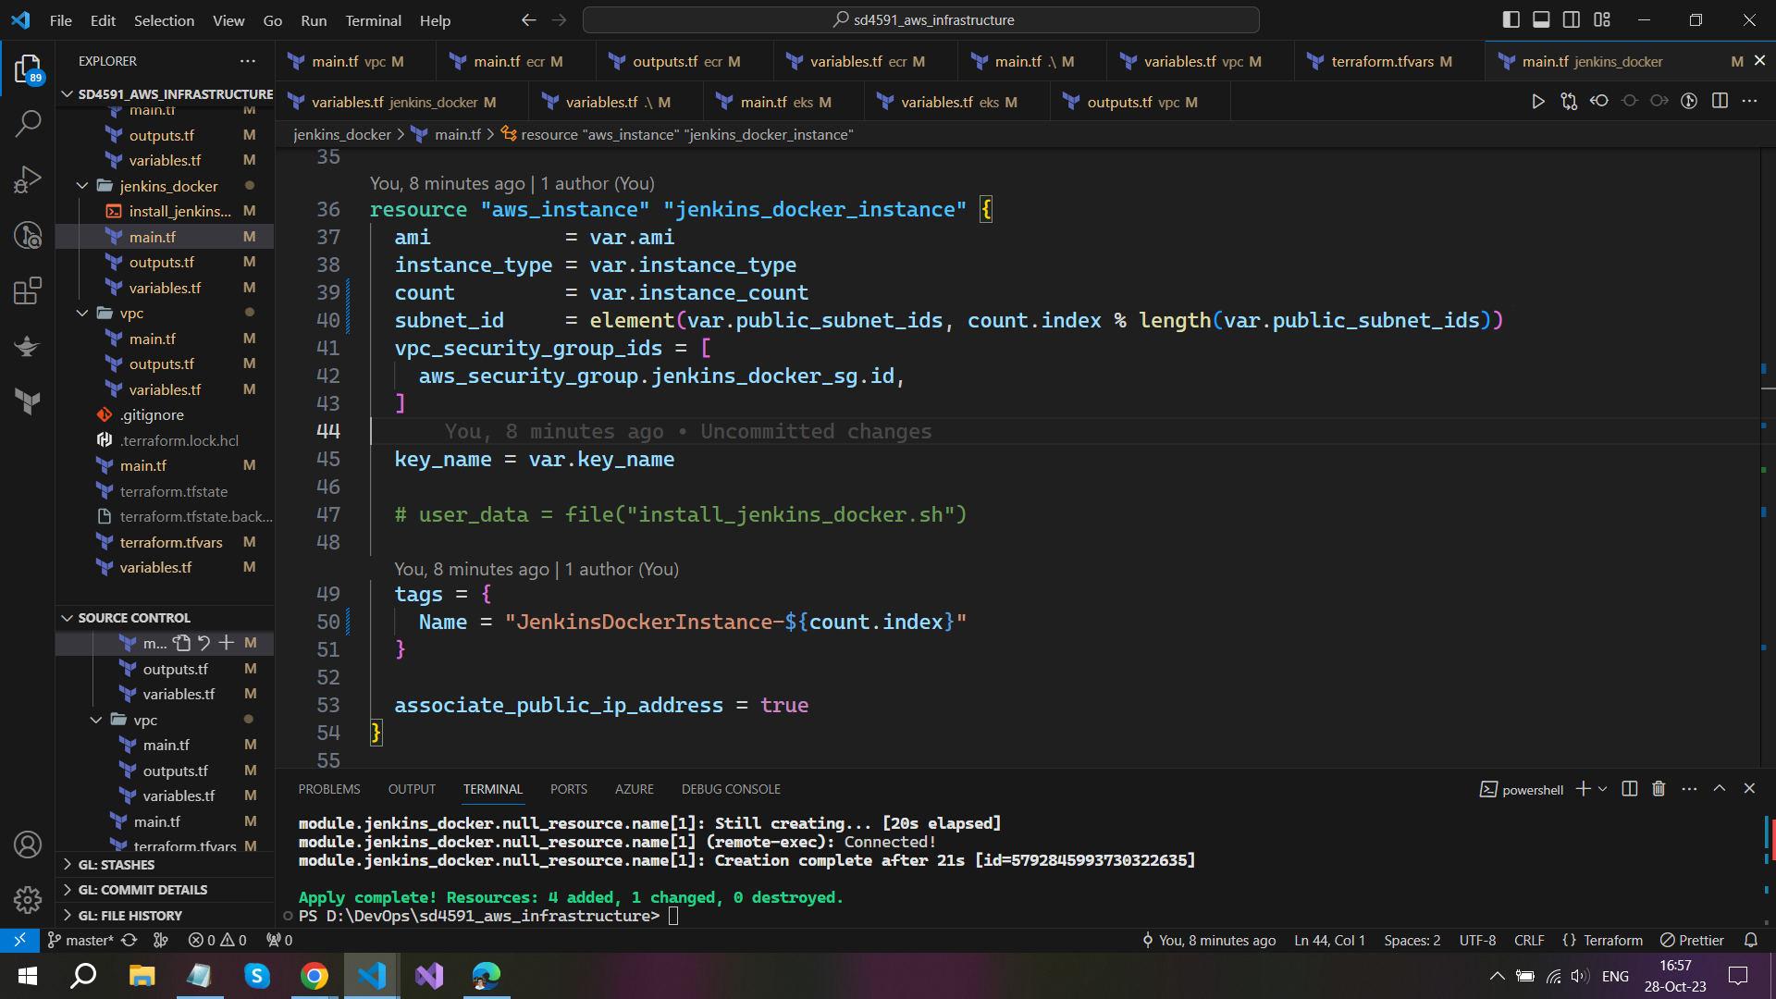**My subnets on multiple zones**

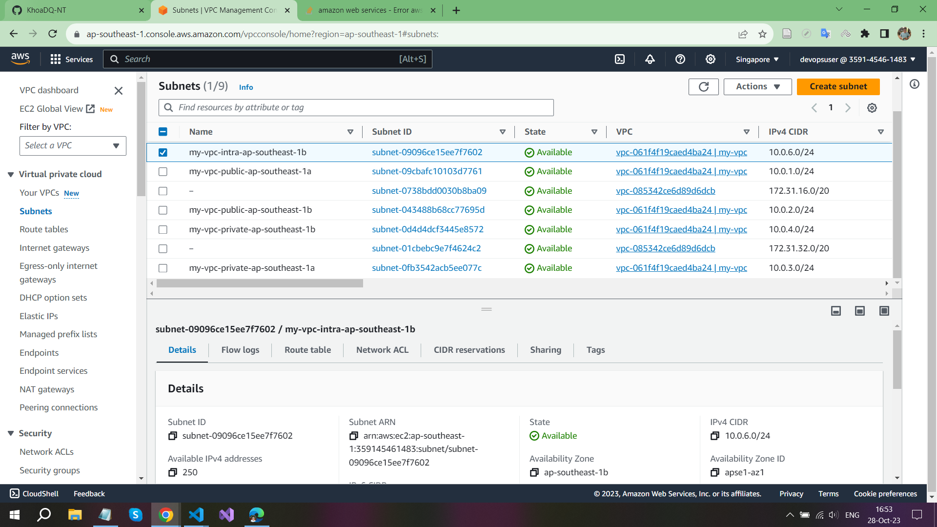

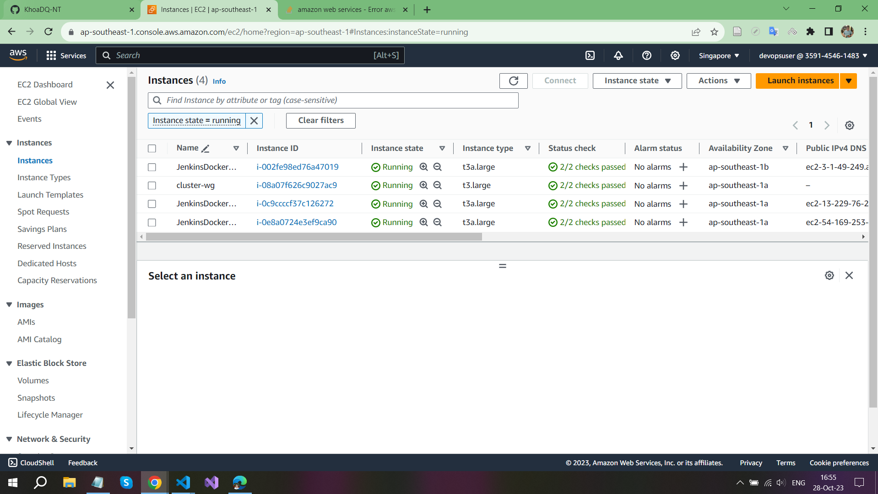



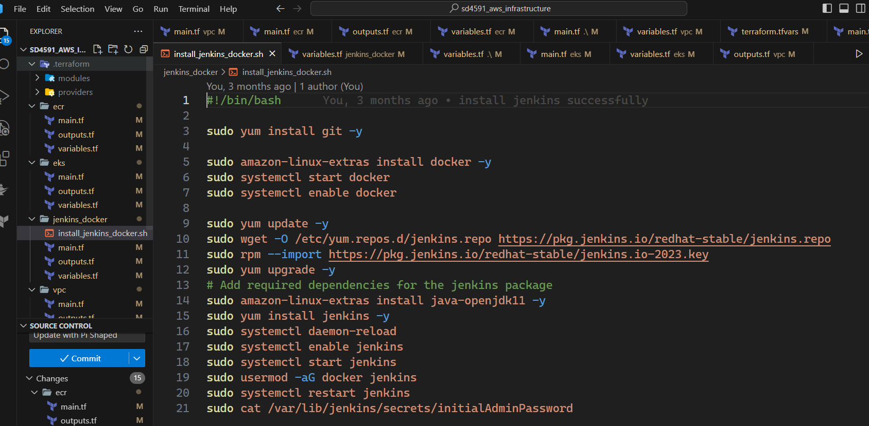

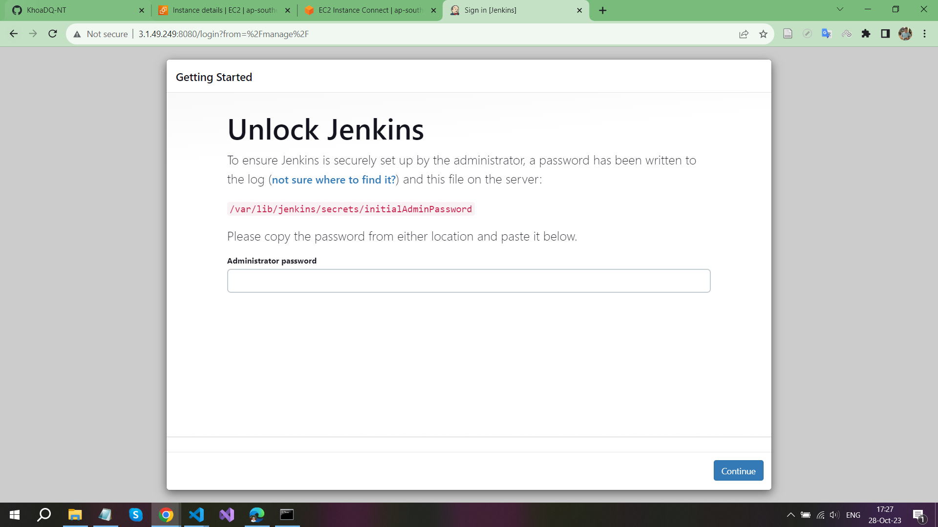

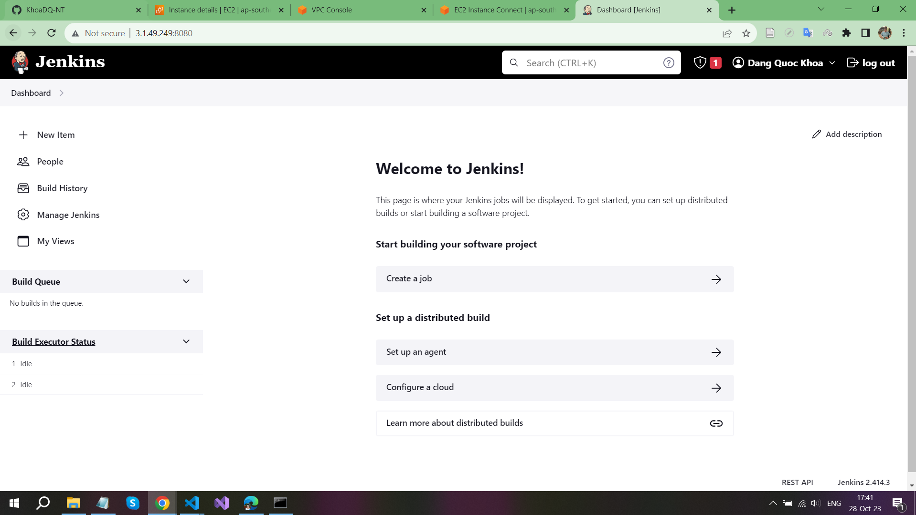

**After Jenkins have been installed, we need to add some needed blugins and create some necessary credentials.**

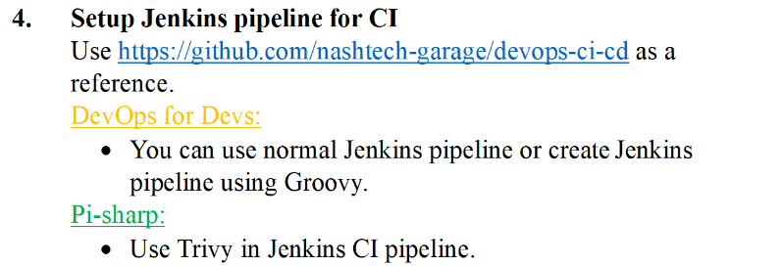

**Trivy should be installed before running the Jenkins CI pipeline**

**curl -sfL https://raw.githubusercontent.com/aquasecurity/trivy/main/contrib/install.sh | sudo sh -s -- -b /usr/local/bin v0.18.3**

**curl -sfL https://raw.githubusercontent.com/aquasecurity/trivy/main/contrib/html.tpl > html.tpl**

**Besides, I have changed MSA source code to add more stages related to Trivy and use it on Jenkins CI**

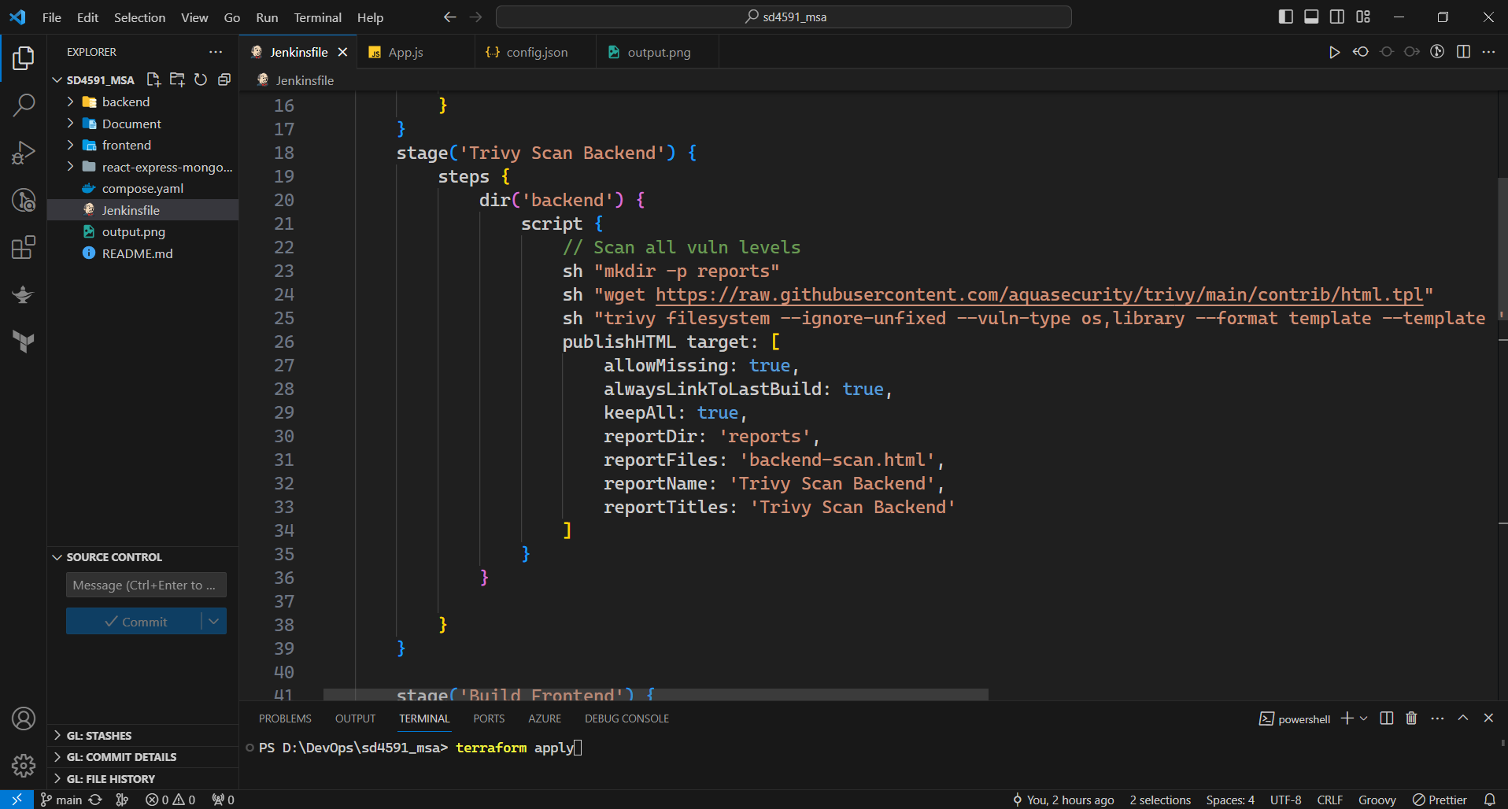

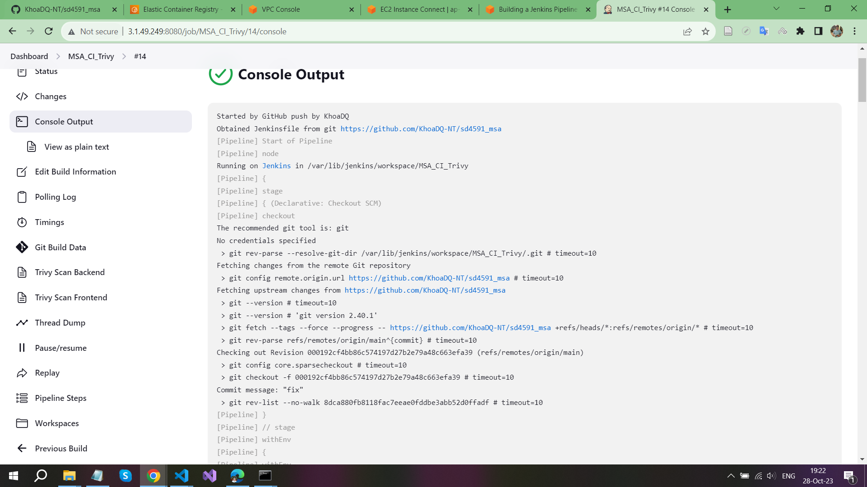

**Build backend** 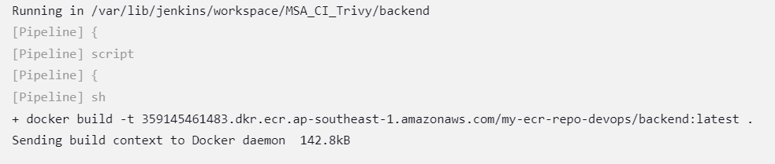

**Use Trivy scanner on Backend**

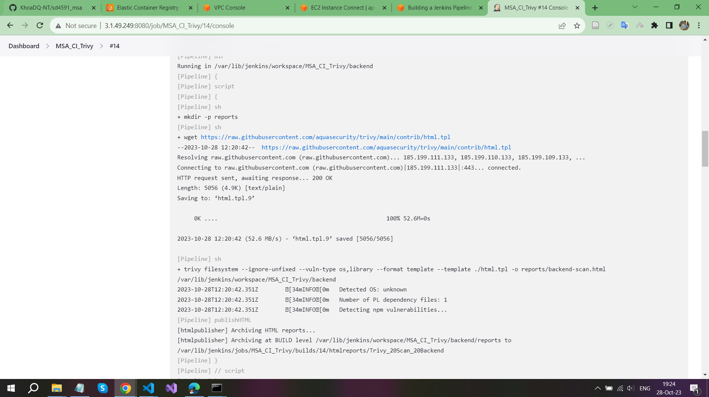

**Build frontend**

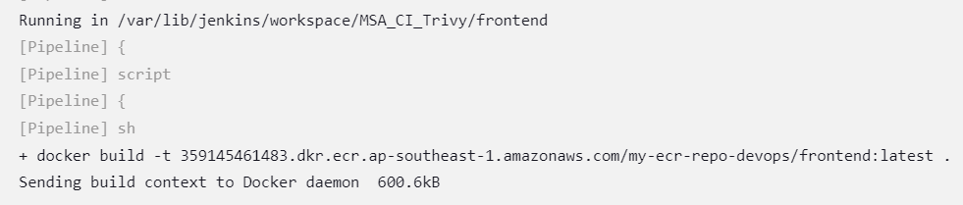

**User Trivy scanner on frontend**

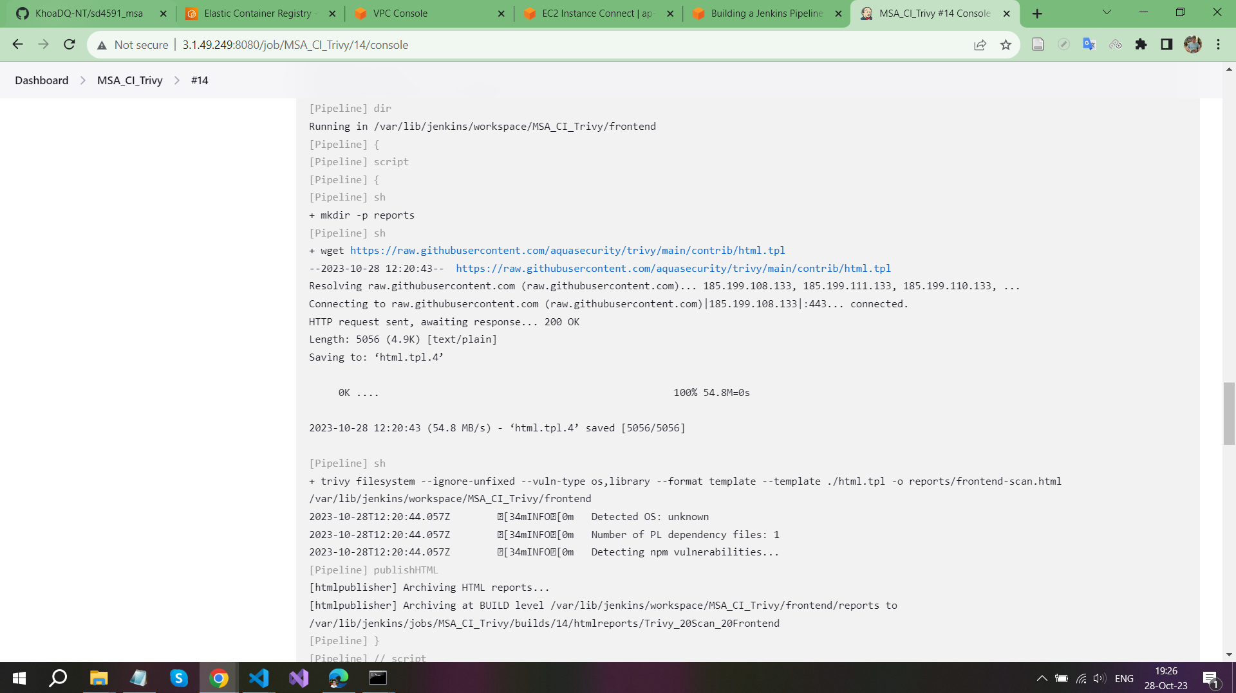

**Push image into ECR and complete CI pipeline**

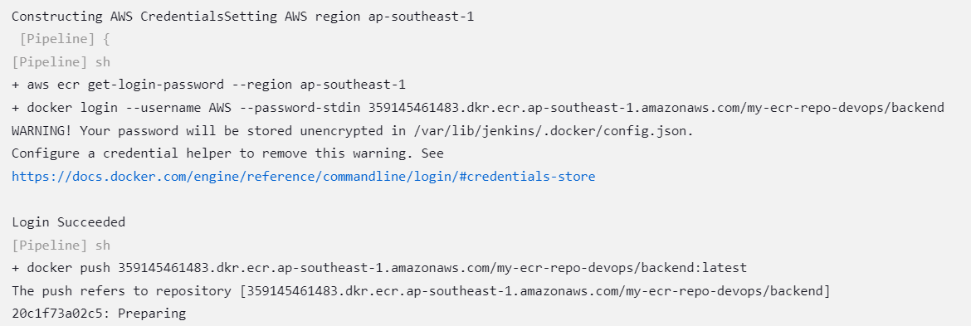

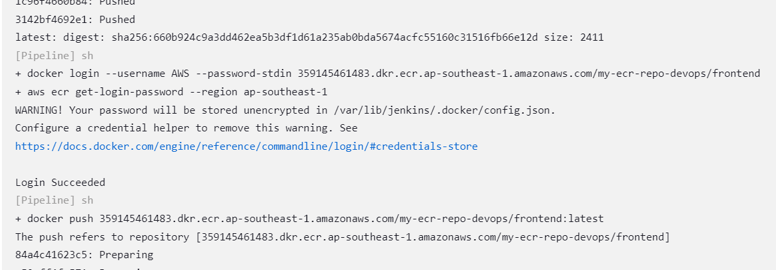

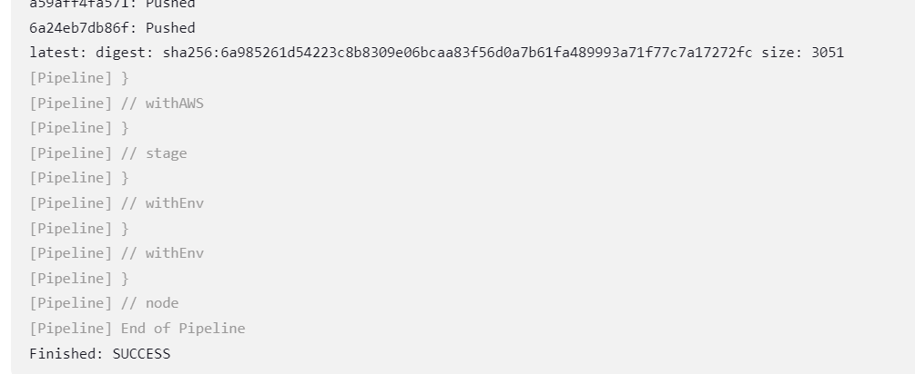

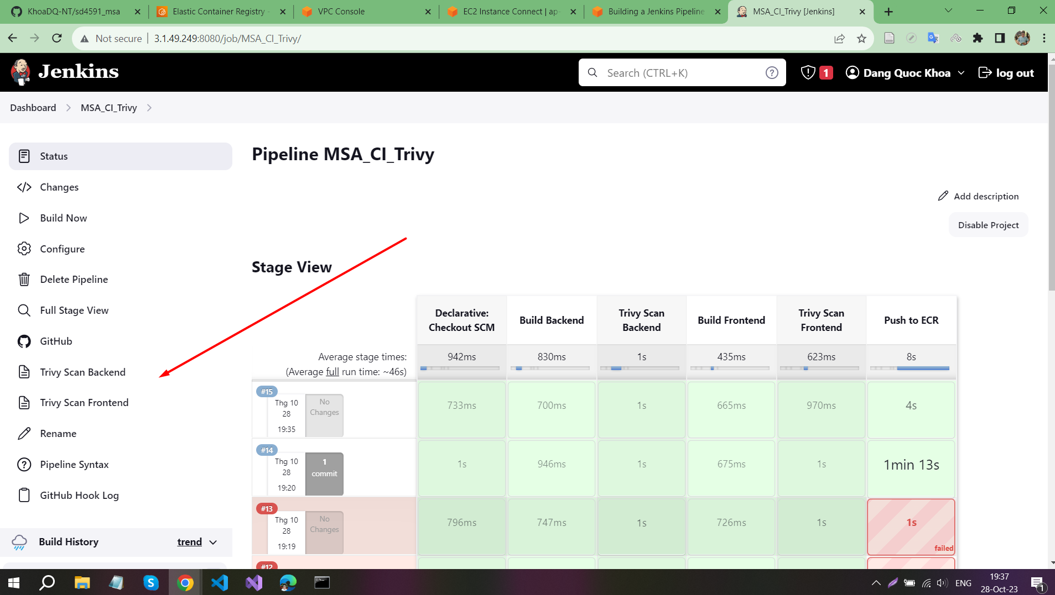

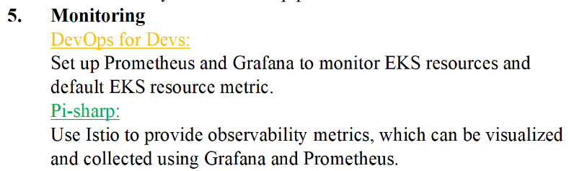

**Download Istio Deployment Files**

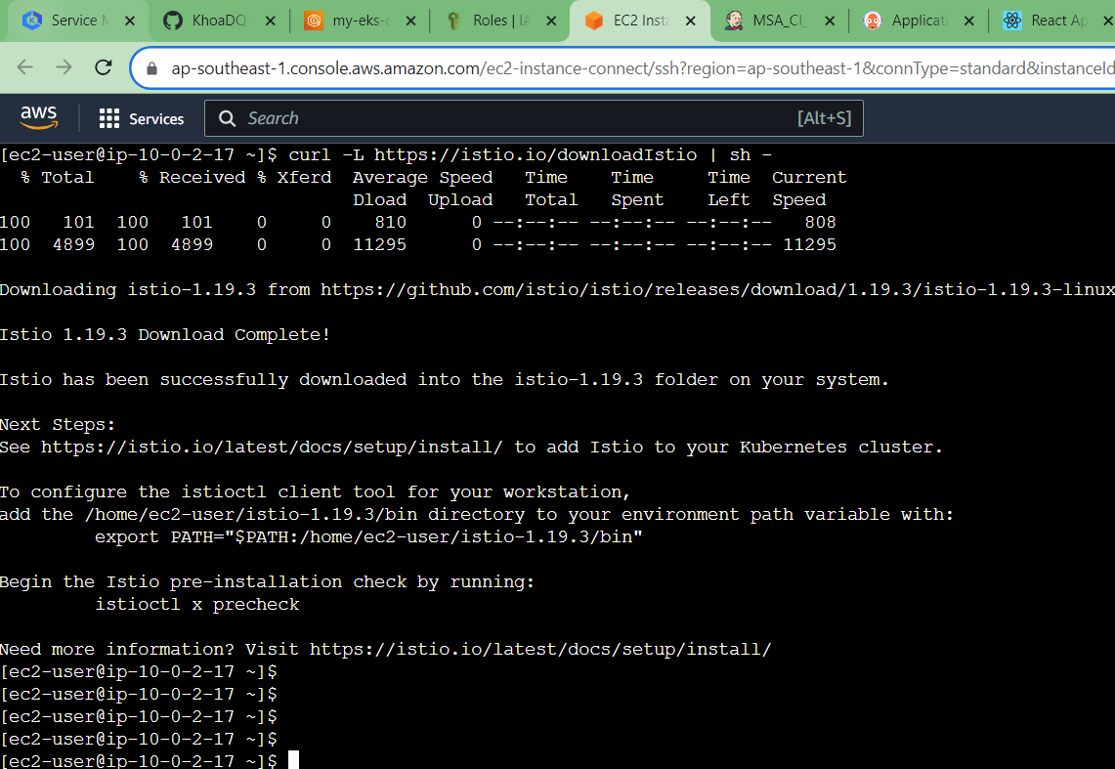

**Configure Helm**

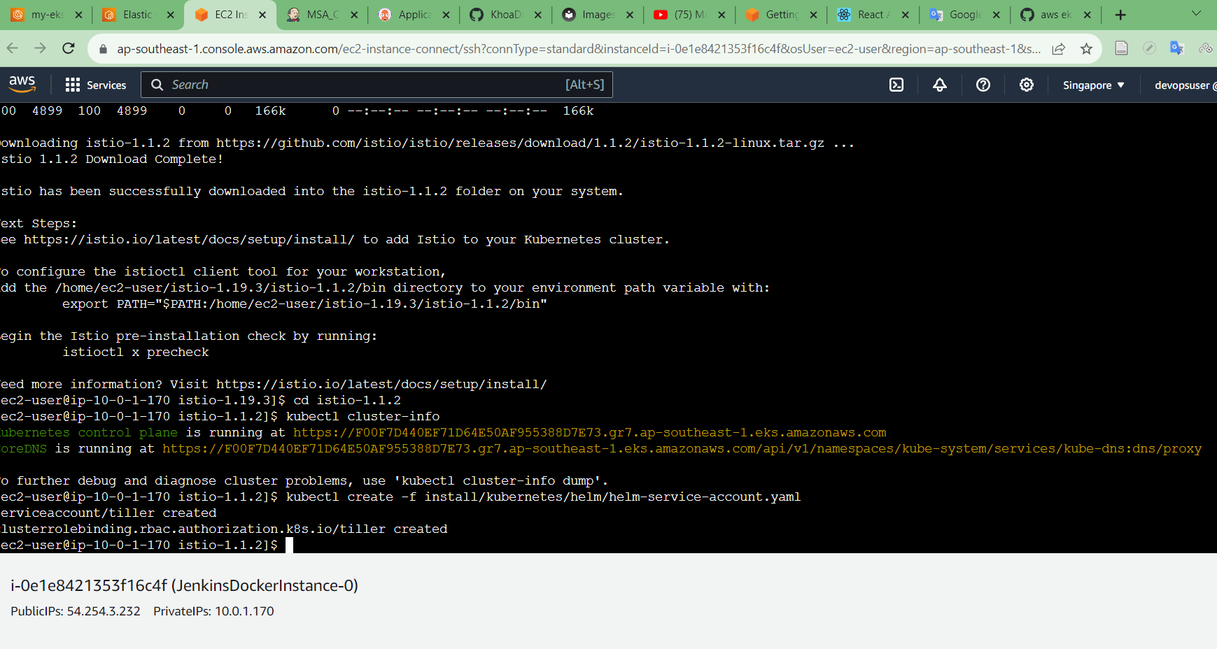

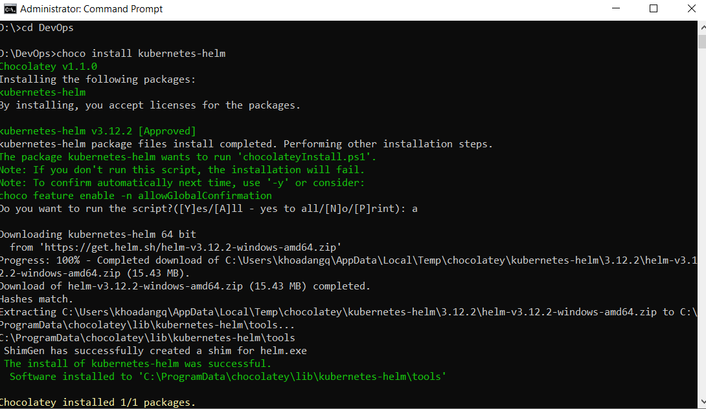

**Prometheus**  
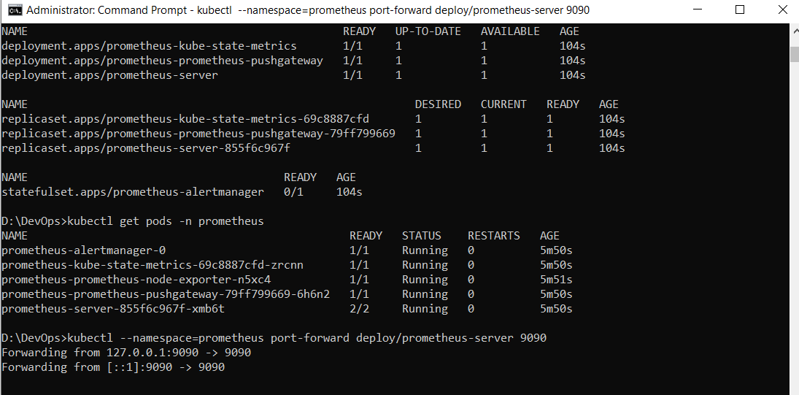  
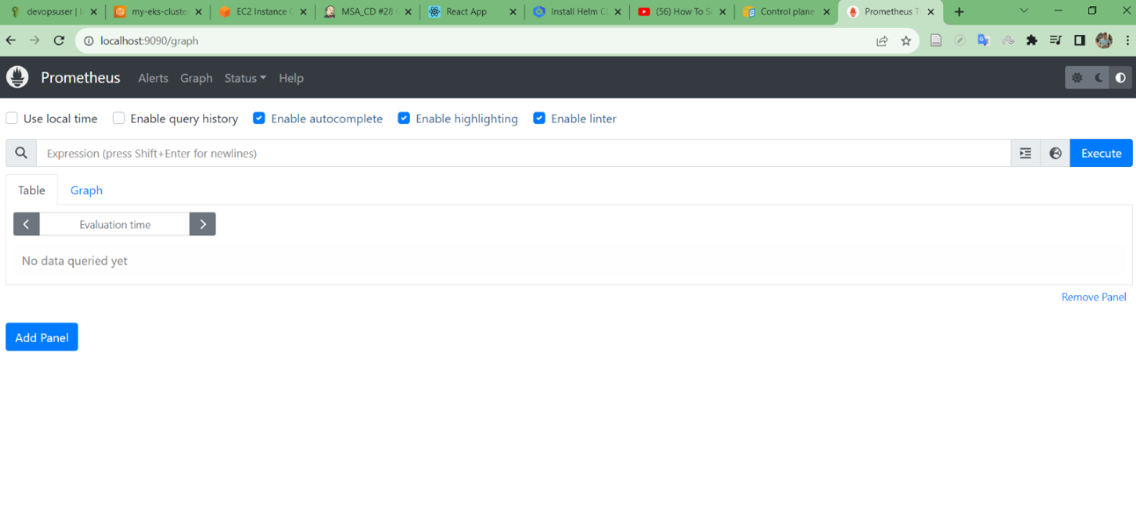

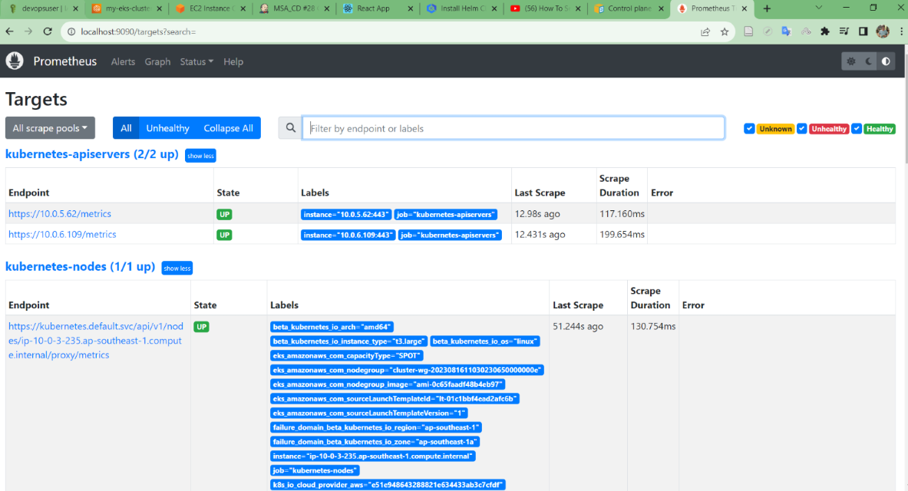

**Grapfana**

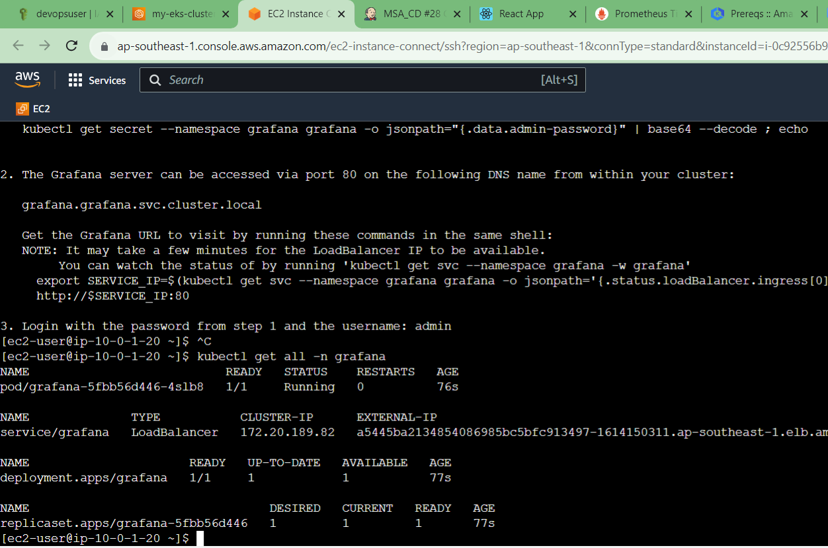  
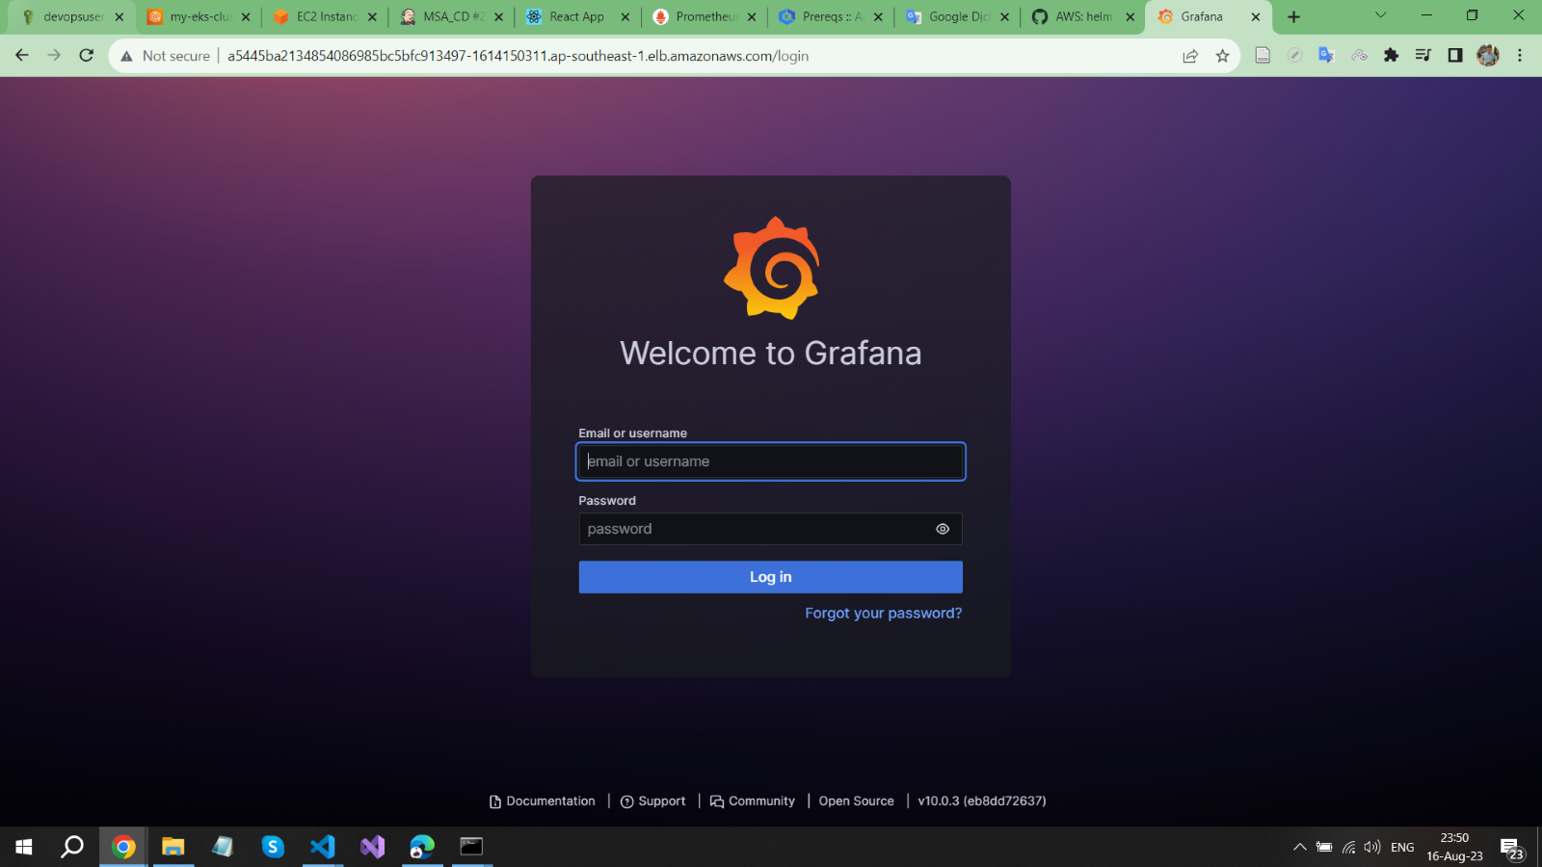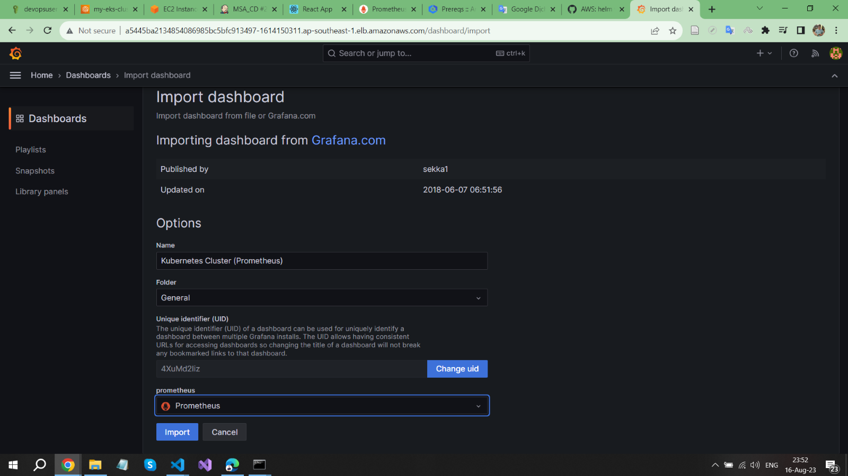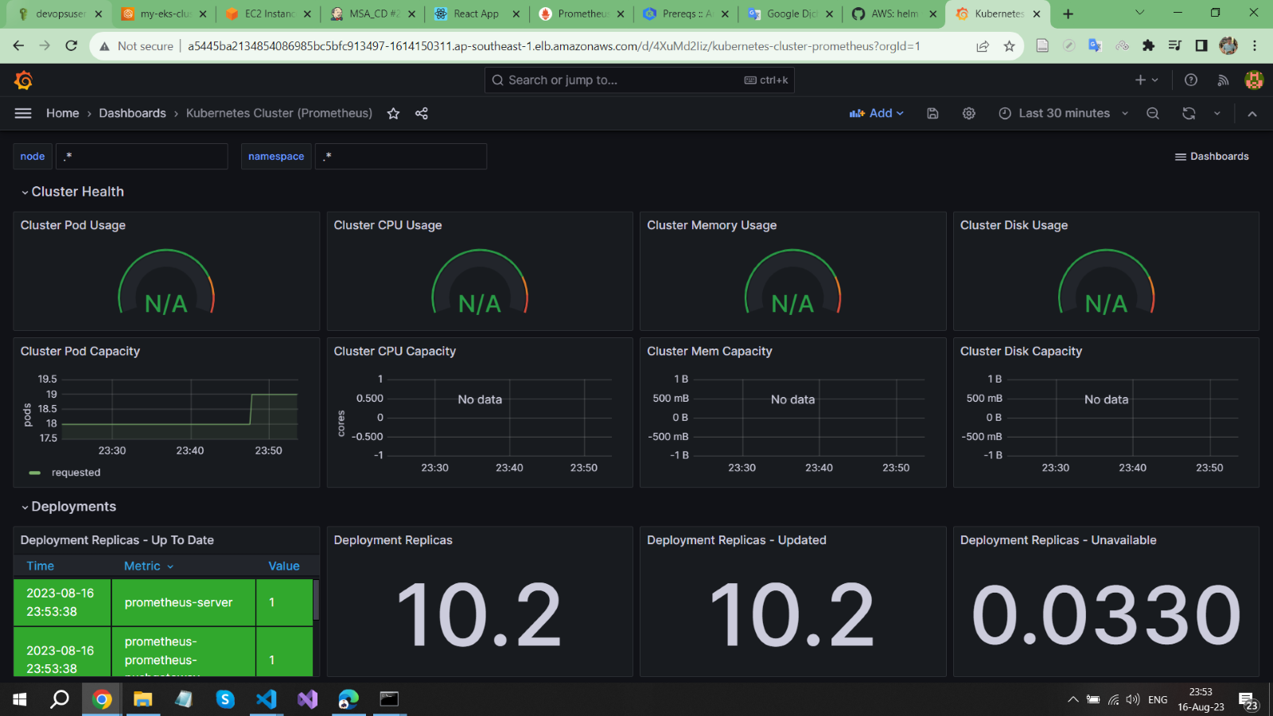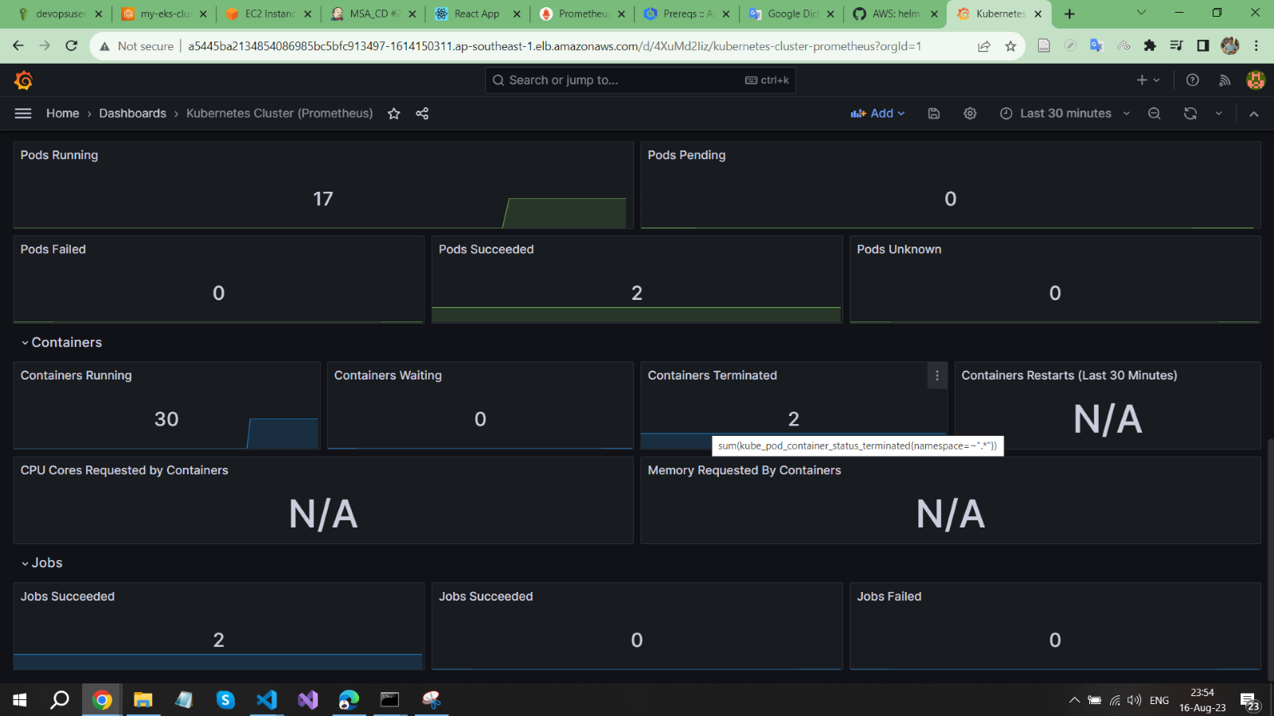

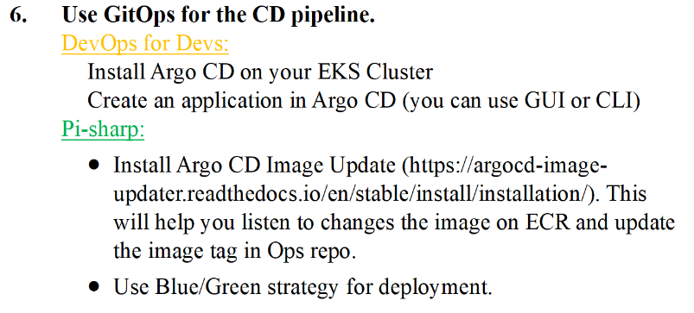**Using ArgoCD Image Updater**

**Install ArgoCD Image Updater and make some necessary configurations**

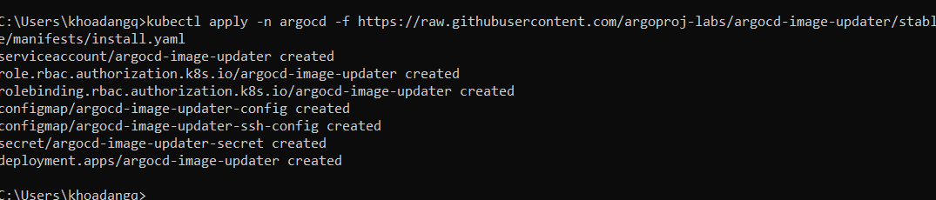

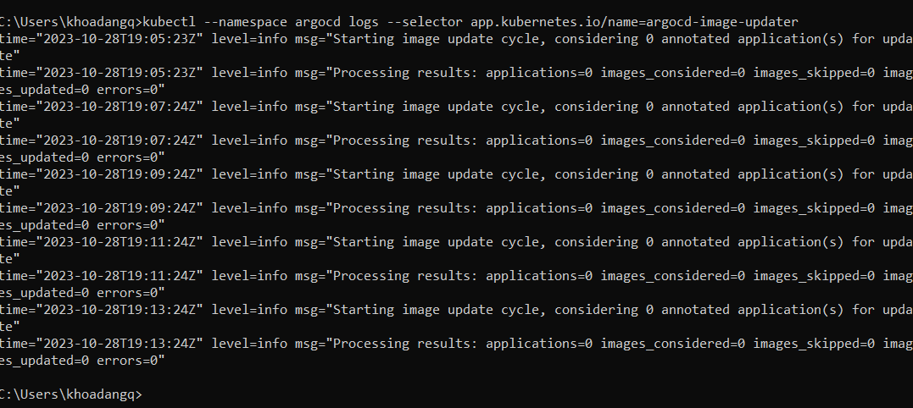

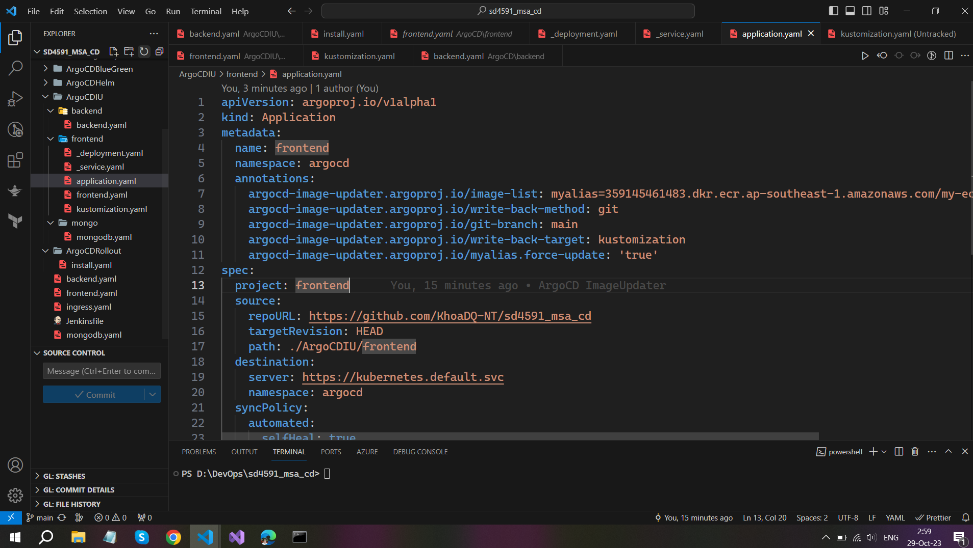

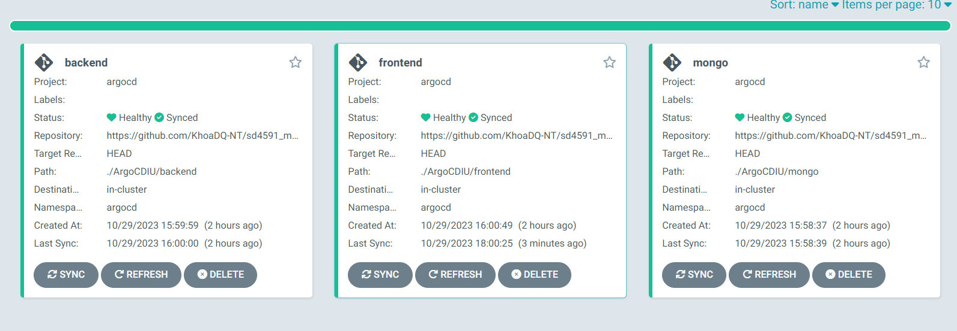

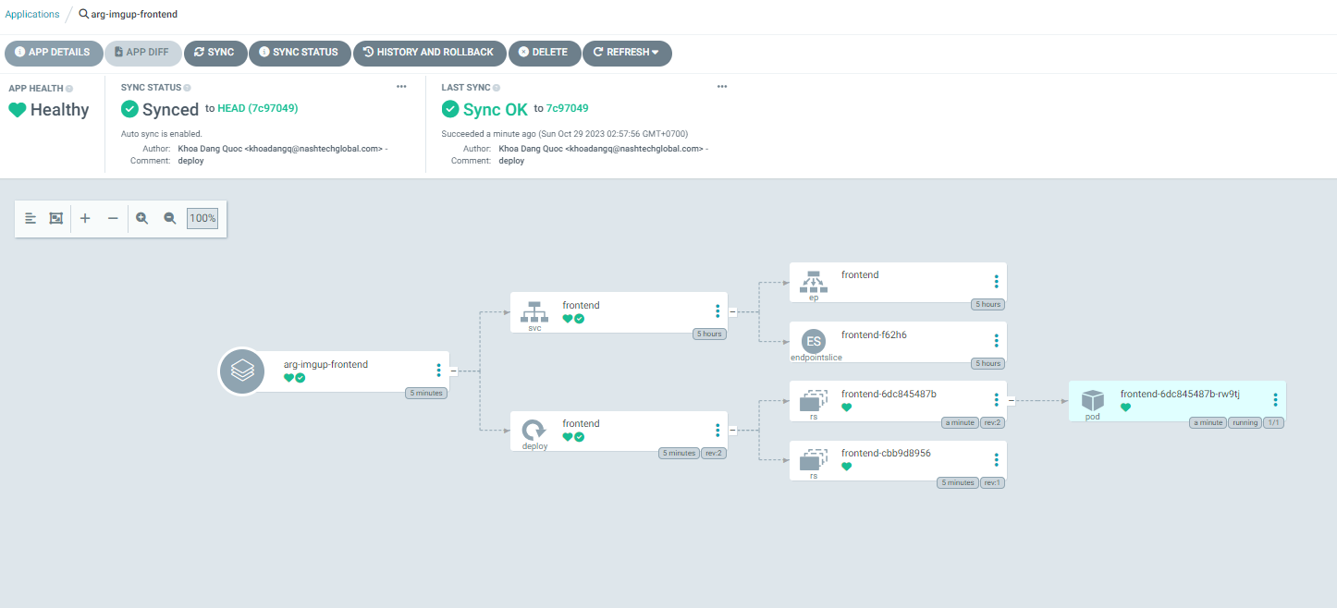

**I did try to find any problem, but it still did not work.**

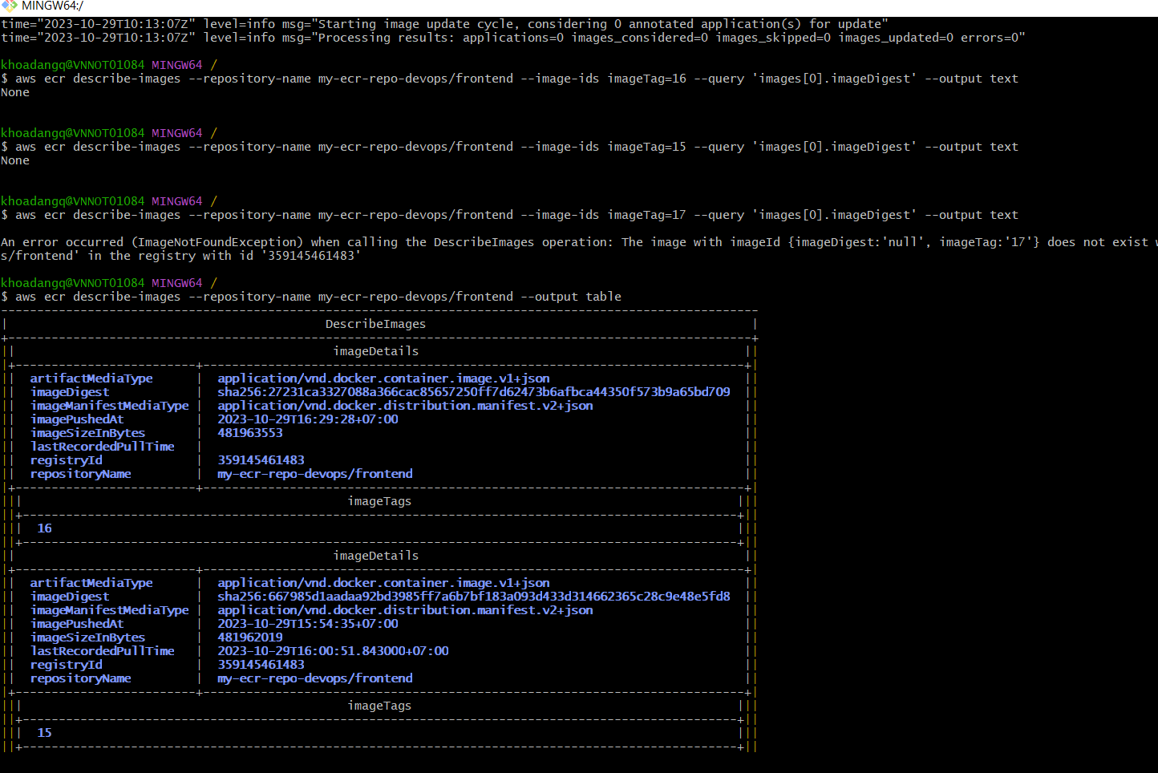

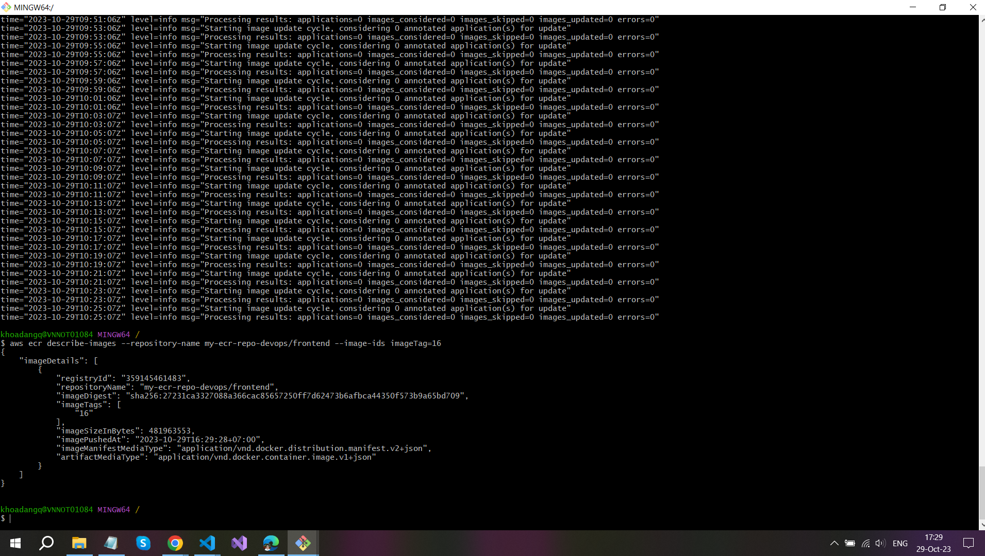

**ArgoCD Image Updater cannot detect new images, so they do not perform any operations in GitHub Actions. Synchronization still must be done manually. I will take more time to learn later.**

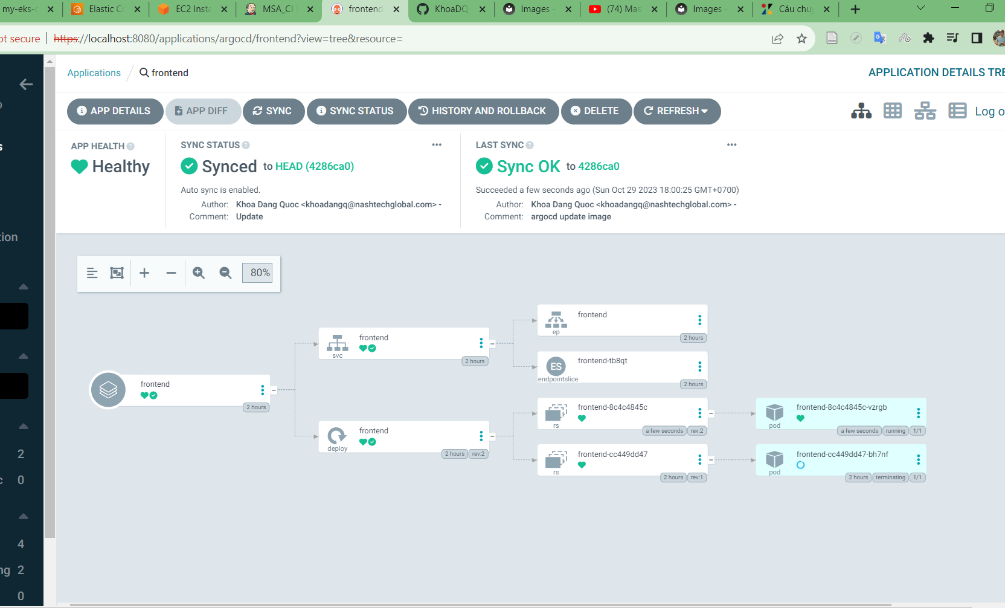

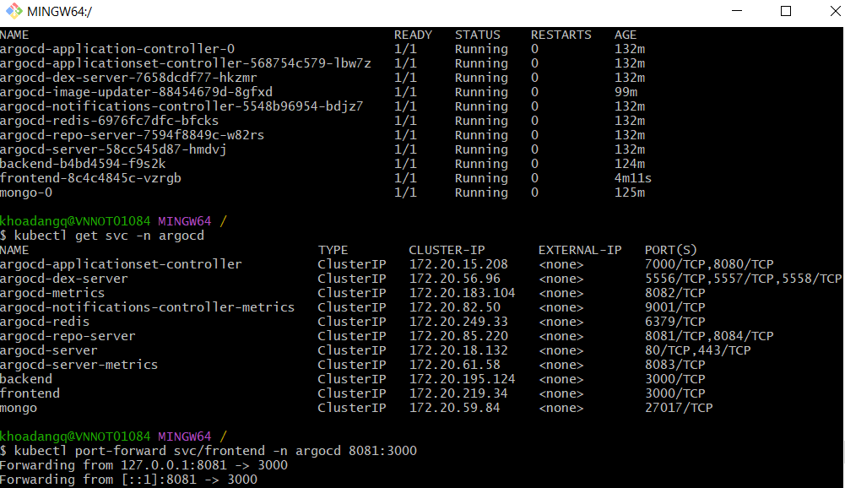

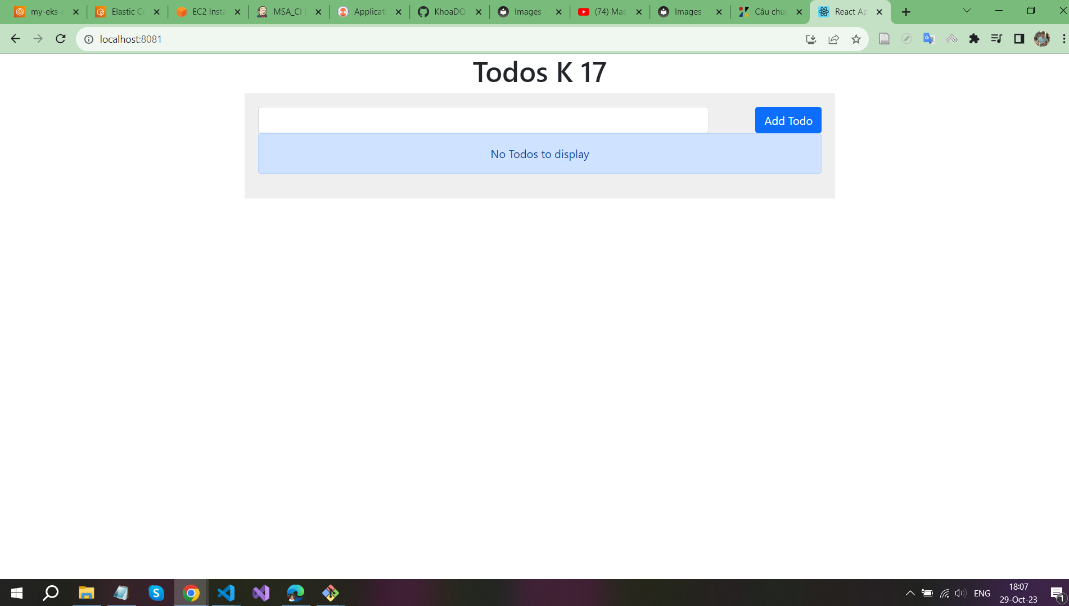

**Use Blue/Green strategy**

**Install rollout-machine to switch between blue and green version of our application**

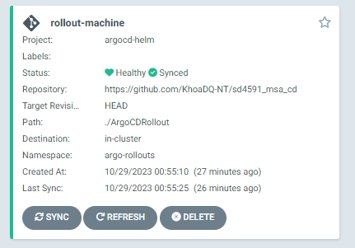

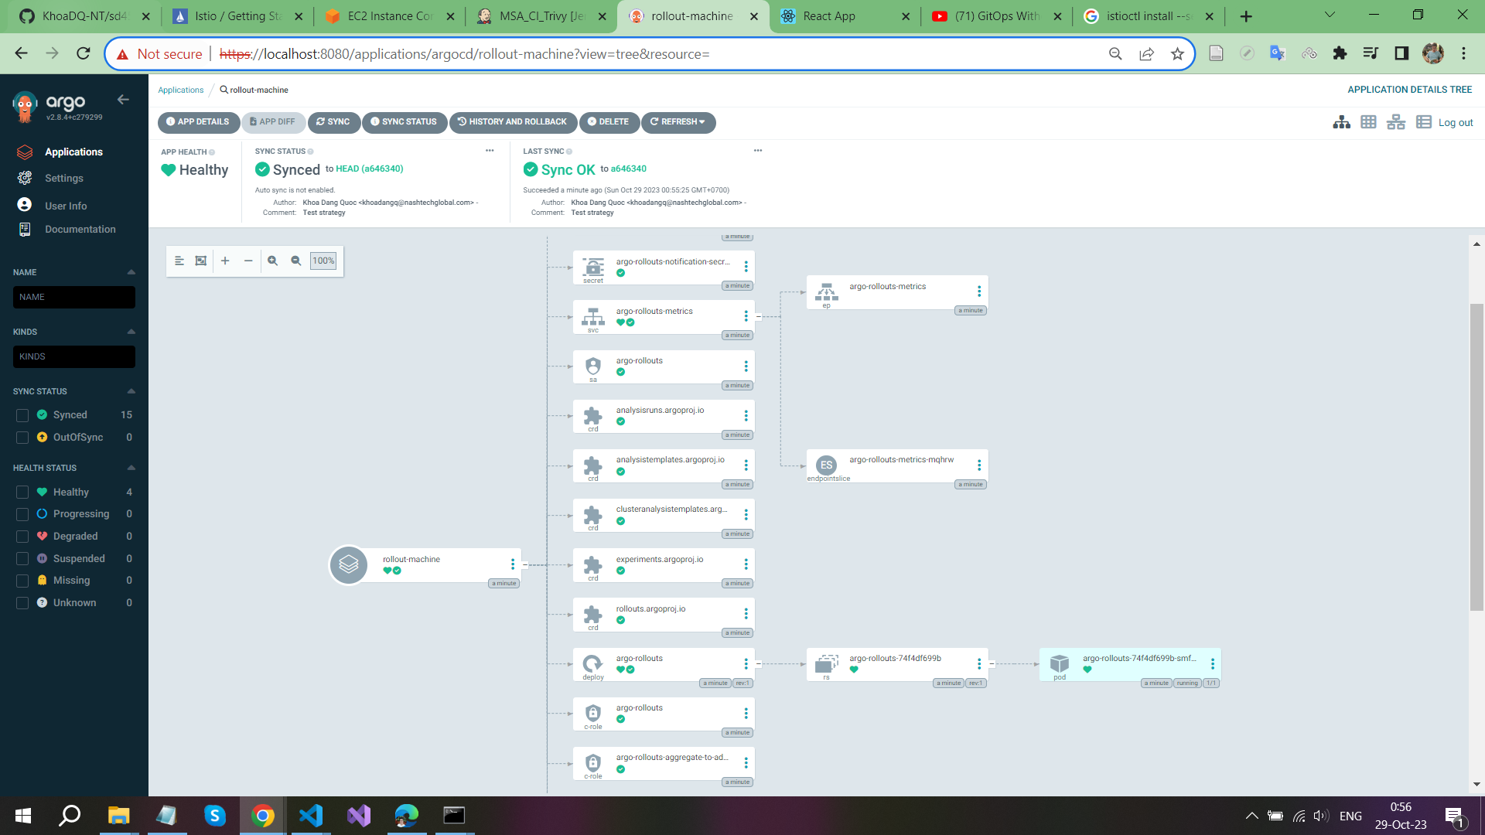

**Create blue-green-app that will get deployment based on image version change**

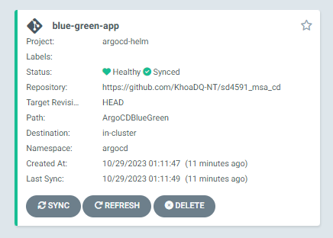

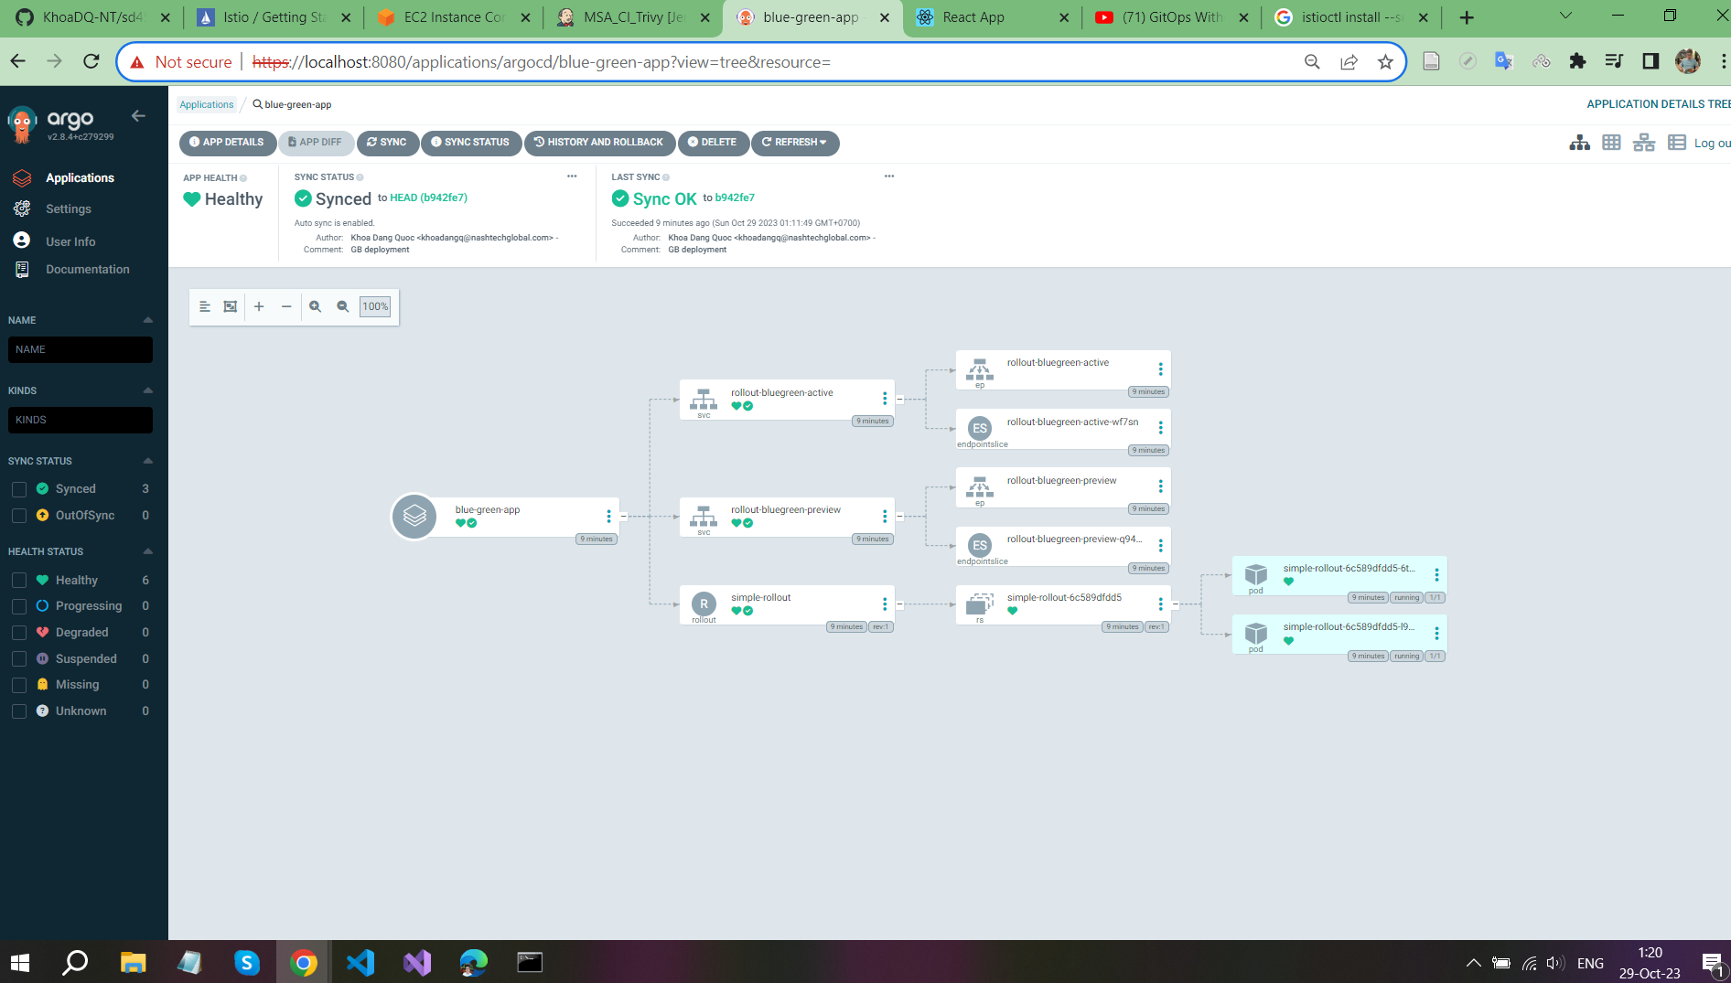

**Check first deployment**

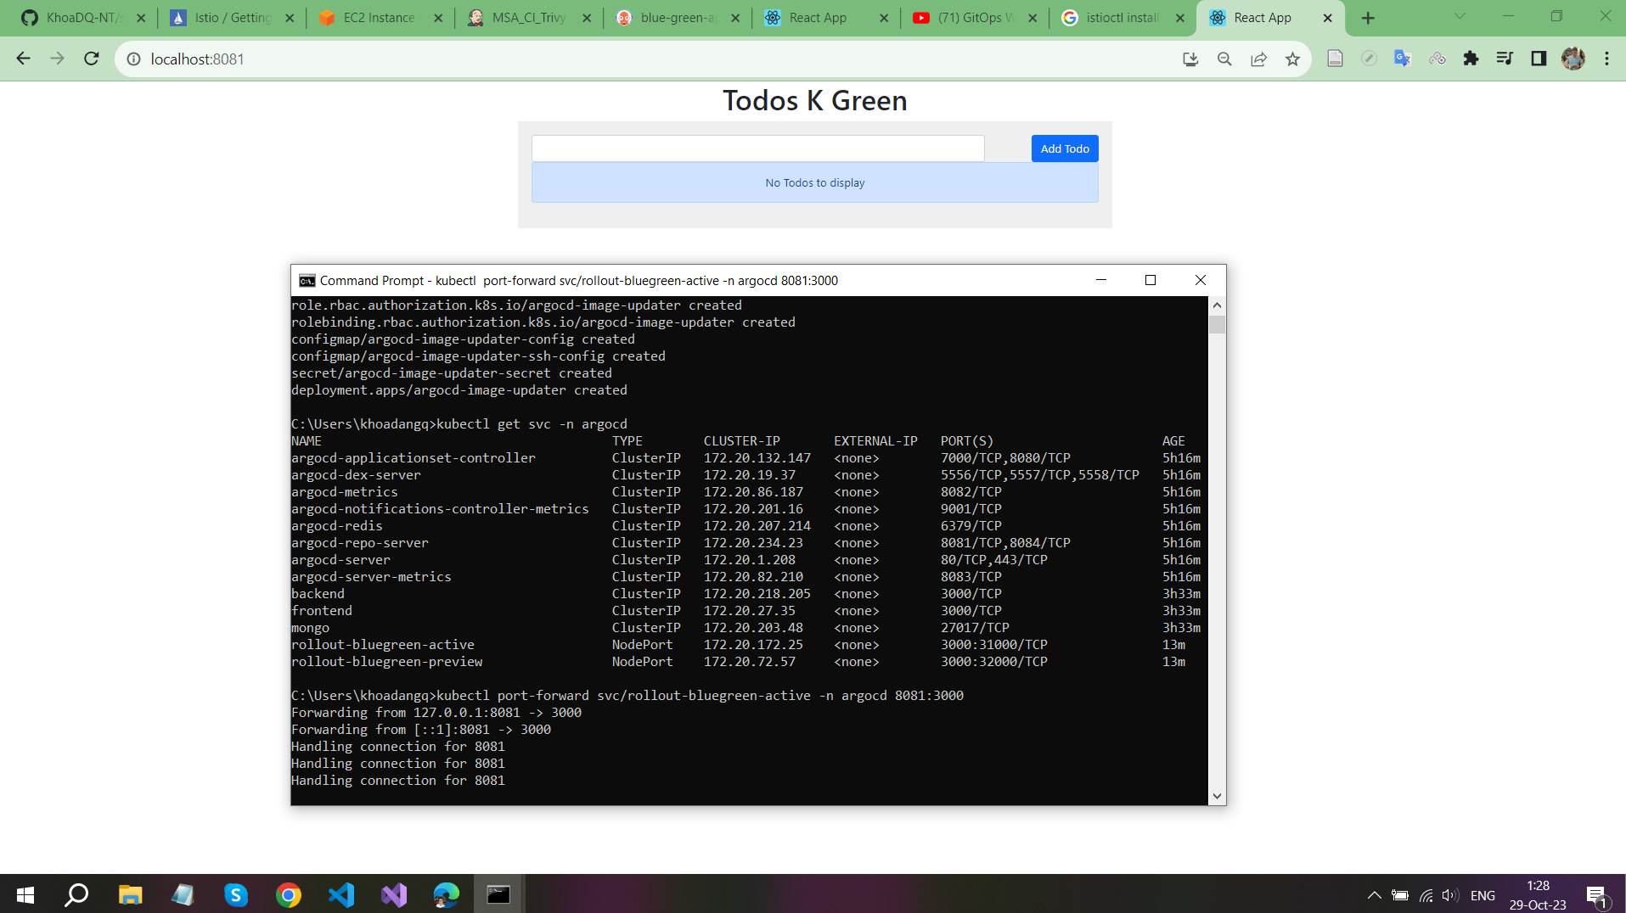

**After changing the image, some actions will be processed:**

**- ArgoCD trigger the changes and have a replica version of application**

**- Argo Rollouts creates another replica with the new version**

**- The existing version still works and gets live traffic**

**- ArgoCD will mark our application as out-of-sync**

**- Until the appplication blue-green-app is synchronized and the new version is completely initialized. Our web application will be switched to new version for using**

**After the changes were applied, forward port if it’s necessary and continue to use the application**

